Website of train description

Kirandeep Kaur

Continental institute of international studies

IMDW-18014

Asst. prof. Amandeep Singh Sohal

November 12, 2018

**DESCRIPTION**

**WEBSITE:**A website of train is the most successful and famous website of the India. It contain all information about the routes of the rail and information about the delay and cancelled route of the train. The train travelling is very cheap and comfortable. Because it cover the long distance in less time period as compared to the buses and other vehicles. It also describe the routes and fare description of the trains. It also include the AC seats and simple seats according to choice of the passengers. A passenger train consists two ends locomotive and several coaches.

**FEATURES:**

* Traffic Planning
* Operation **Management** System
* Power Supply and Infrastructure
* Operation Information for Passenger
* Operation Information for Staff.
* Maintenance Support
* Driver-Only and Driverless Operation.

Main steps and features of the train website is the planned the traffic and rules to decrease the traffic and accident by the train. Maintain the policies of the train to the driver and passenger. Give all information to the passenger regarding the train, ticket and seating planning.

**Purposes:**

* To entrain or detrain passengers.
* To load and unload goods and parcels.
* To control the movement of trains.
* To enable trains to cross each other in the case of a single line section.
* To enable faster trains to overtake slower one.
* The main purposes of the website to give information to the passenger about the routes of the train.
* To enable locomotives to refuel whether it diesel, water, coal.
* Give information about the facilities in the train.

**Business model:**

Plan the goal what are the main routes of the path. What are the main features and duties of the staff? Describe the main criteria of the website. The various steps are include in the business model of the railway:

Collect feedback

Take effort to complete the project

Develop a project

Steps to fulfill the goal

Plan the goals

Take all efforts to complete the tasks.

**USE CASE**

Responsible for the loss

Misconduct with the railway goods

Responsibility of non-delivery of product

**Administrator**

Responsibility for consumer loss

Responsible forto maintain the financial condition.

Maintain the environment of railway

**User**

Check the staff honesty and way of working

To collect the fine from undisciplined passenger

Check the ticket

**Ticket master role**

Control the inquiry counter

Responsible for to distribute the ticket

Responsible for the safety

Responsible for the running of train

**Station master**

Responsible for the management

Responsible for the other station

**Description of use cases**

Responsible for other station

Running of train

Responsible for management

Distribute the ticket

Check the ticket

Collect fines

Control inquiry counter

Railway services

Maintain the financial condition

Delivery of product

Goods responsible

Services responsible

Consumer loss

Staff services

Safety

Station master

Ticket counter

Administrator

User

Duties

**Role of administrator:** The main role of administrator to control the delivery of the product and responsible for the non-delivery of the product. He also control the services and goods. They also responsible for the consumer loss.

**Role of user:** The user check the staff working style and their responsibility. The user maintain the financial condition of the railway. They also give feedback about the services of the railway.

**Role of ticket counter:** The t**icket** counter have significant role to check the tickets of the passenger. They also collect the fine from the passenger. They also control the inquiry counter and distribute the tickets.

**Role of station master:** The station master control all the services of the train. For example: running of train, control other station, safety, responsibility of management.

**Content plans**

Welcome to the train website to know about the train description and train fare description and train routes. For the online shopping for booking the tickets. The most preferable place for the ticket booking and for the login place. The prototype also describe the running status of the train and timing of the train. The train destination period of the train according to the timing of the travelling of the train. The seat matrix of the train. The seat distribution of the seat is according to budget of the customers and consumers.

.



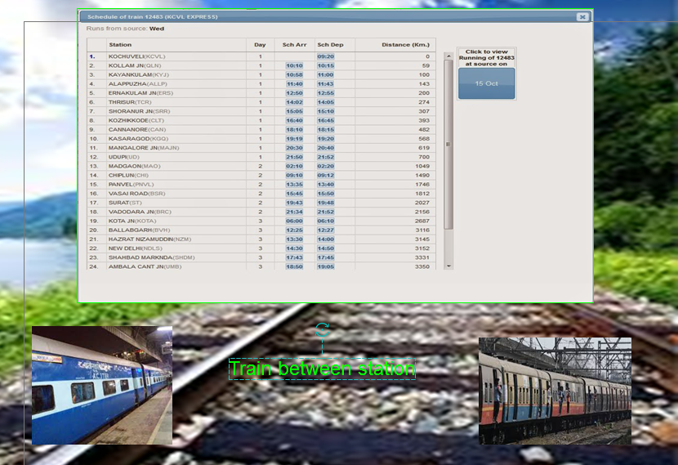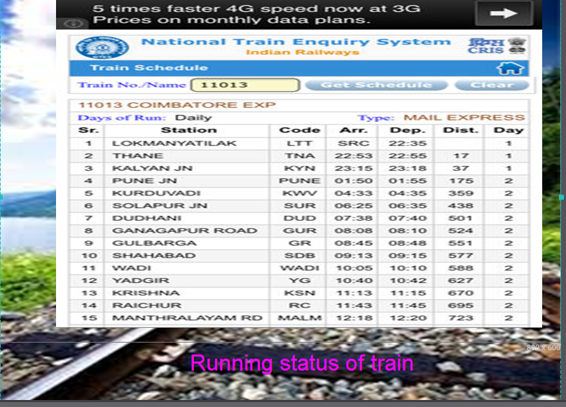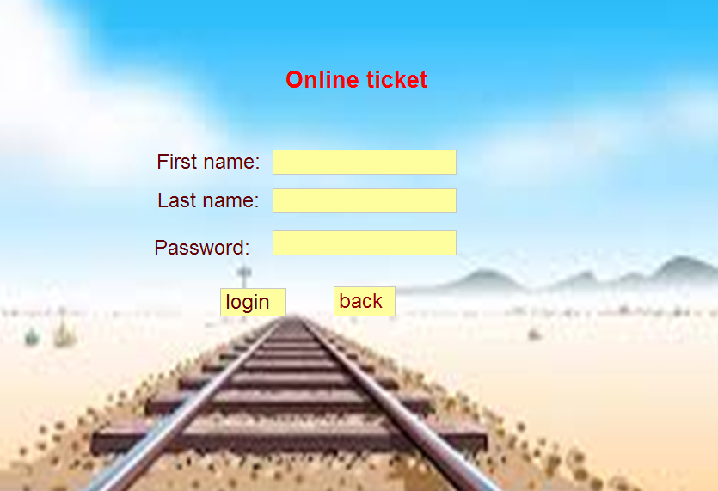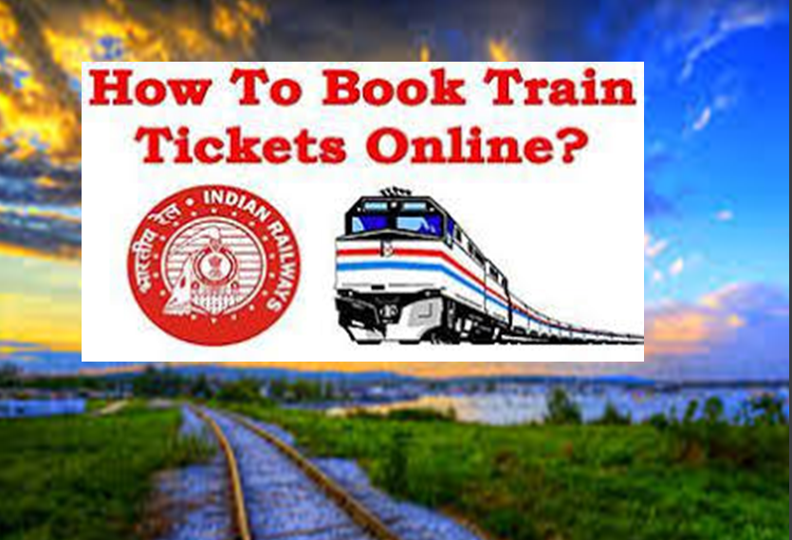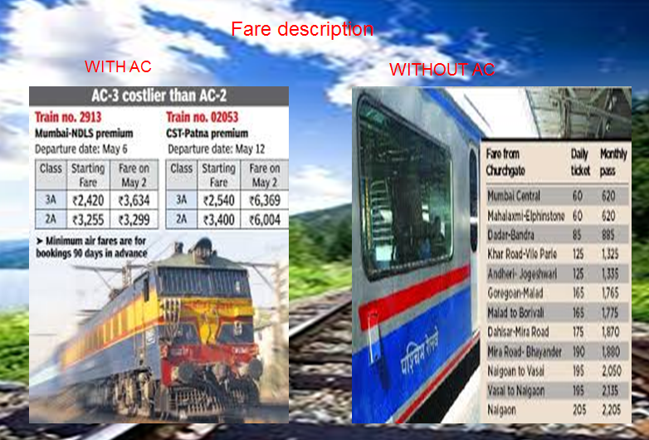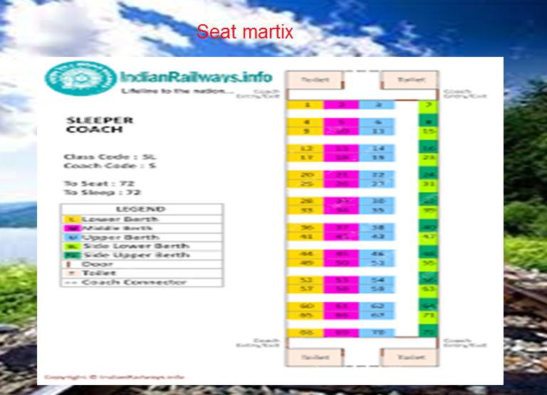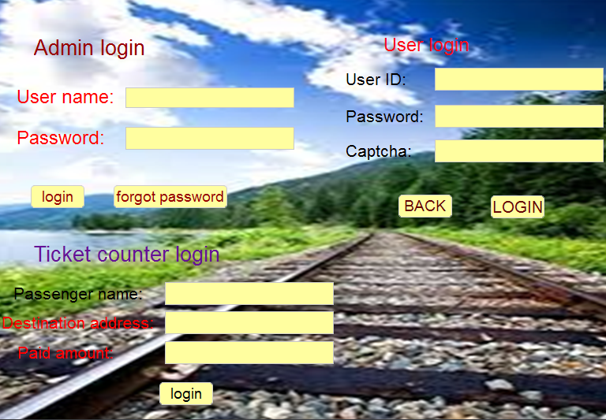

Refrences

<https://www.yatra.com/indian-railways/indian-train-routes>